**Implementation of INVENT project**

**at**

**The University of Jordan**

**July 24, 2018**

**Document Data**

|  |  |
| --- | --- |
| **Distribution List** | Choose from:  **PU** (Public)  **RE** (Restricted to a group specified by the Consortium (including the Commission Services)  **CO** (Confidential, only for members of the Consortium (including the Commission Services) |
| **Document Version** | 0.1 |
| **Reviewed by** | Name of reviewer(s), Organisation(s) |
| **Review Date** | dd/mm/yyyy |

|  |  |  |
| --- | --- | --- |
| **Version** | **Date** | **Author/Organization** |
| 01 | June 12, 2018 | Prof. Ahmed Al-Salaymeh /The University of Jordan  Eng. Leena Marashdeh/The University of Jordan |
| 02 | July 24, 2018 | Prof. Ahmed Al-Salaymeh /The University of Jordan  Eng. Leena Marashdeh/The University of Jordan  Eng . Tahani Adi |
|  |  |  |

**Disclaimer**

This project has been funded by the Erasmus+ Programme of the European Union.

The information and views set out in this publication are those of the author(s) and do not necessarily reflect the official opinion of the European Union. Neither the European Union institutions and bodies nor any person acting on their behalf may be held responsible for the use which may be made of the information contained therein.

Reproduction is authorized provided the source is acknowledged.

Copyright © INVENT Consortium, 2015-2017

**Table of Contents**

1 Executive Summary 4

2 CTI-UJ Achievements 5

2.1 Training workshops and info days: Prepare and conduct internal/external information events, and conferences 5

2.2 Workshops and exhibitions 7

2.3 Cooperation Agreements for sustainability 8

2.4 The implementation of Innovation and Creativity courses 8

2.5 The Regional Seminar on "Technological Innovation in Water for Sustainable Development" 10

# Executive Summary

This report is summarizing the achievements and activities of the Centre for Transfer of Innovation (CTI) at The University of Jordan.

The centre at UJ is helping in implanting and developing the National Policy and Strategy for Science, Technology and Innovation which is the base of all currently on going and planed innovation support activities. The development of a framework for supporting entrepreneurs to help them getting their innovative ideas transferred into the markets is in fact very essential and it is obvious that it cannot stop after the end of the INVENT project.

CTI-UJ is seeking to establish a cooperation between representatives from research, student and business sectors and investors and the university. INVENT project will enable the CTIs to support reality-related introduction of research results into the educational processes and industrial application.

The role of the University of Jordan in this project include Improving connections between higher education, industry, and society, satisfying industry and economical needs by empowering target groups with limited access to research resources, Developing the innovation centers and to ensure that efforts are not duplicated, Participating in surveying and benchmarking activities.

# CTI-UJ Achievements

The CTI at the University of Jordan is implementing many activities to promote the innovation idea and assure the sustainability of the center after the end of INVENT project.

These activities could be summarized as follow:

## Training workshops and info days: Prepare and conduct internal/external information events, and conferences

1. Hosting of Mr. Marwan Juma, former Minister of Communications and Information Technology and Chairman of Oasis 500.
2. Entrepreneurship competitions in partnership with various parties
3. Hosting Ahmed Al-Ashqar Executive Director of the competition Hult Prize
4. A lecture entitled "Developing Marketable Entrepreneurship and Partnerships with the Private Sector" was delivered by Dr. Don Ross, Director of kick start at the University of North Carolina, USA.
5. Opportunities for Innovation and Leadership for Youth in Jordan Business School "Global Entrepreneurship Week".
6. Innovation and Entrepreneurship in Information Technology College of Information Technology "Global Entrepreneurship Week".
7. Opportunities for Innovation and Leadership for Youth in Jordan Business School "Global Entrepreneurship Week".
8. "Youth Support, Qualification and Training in Entrepreneurship" by Dima Bibi, CEO of INJAZ to create economic opportunities for Jordanian youth.
9. An open dialogue with Eng. Fares Sayegh on entrepreneurship and media in Jordan
10. A lecture about the Center for Innovation and Entrepreneurship at the University of Jordan.
11. Lecture "The Role of Social Networking Influences in Spreading Awareness and Fighting Extremism".
12. Participated in the final event of the "Peer to Peer: Challenging Extremism" competition in Washington.
13. An open dialogue with His Excellency Mr. Waleed Habasam on "Entrepreneurship in the Technology Sector".
14. Hosting the global competition "get in the ring".
15. Release Program "Empowerment and Youth Development" in cooperation with the Jordanian Hashemite Fund.
16. Exhibition and contest of two projects for pioneering projects in information and communication technology.
17. Hosting Mr. Rami Al-Karmi Chief Innovation Officer, Director of Development and Innovation and Al-Ahli Financial Technology Company - Jordan National Bank
18. Organization of “The International Conference on Technology Innovation, Management, and Entrepreneurship” in 2017.
19. The Innovation and Entrepreneurship Center participated in the Total Renewable Energy Exhibition where two teams from six teams through the center managed to get the first and third positions.
20. Holding a training and competition at the University of Jordan.
21. Conduct a Free Training Course about (Android Programming).
22. "Introductory Seminar on Entrepreneurship and Presentation of the Oasis500 Experience in Entrepreneurship in Jordan and Investment in Leading Companies.
23. The interactive workshop on "Entrepreneurship without leaving your job" with the American author, investor and entrepreneur Patrick McGinnis
24. An open discussion about the experience of the entrepreneur and Dutch Professor Josette in creating companies and factors for success in entrepreneurship and empowering women in entrepreneurship.
25. Hosting the Bader team to talk about the Bader Fellowship and how to register
26. Entrepreneurship Workshop, held on April 18, 2018 for Faculty members and students
27. Organizing the Regional Seminar on "Technological Innovation in Water for Sustainable Development"

## Workshops and exhibitions

A workshop entitled **“Made in Jordan Workshop”**, was conducted on March 26, 2017.

The event aims to introduce the status of the industry in Jordan, and the success stories of some industries. Moreover; the workshop was accompanied with an exhibition for many local companies that succeeded in manufacturing their products in a high quality. INVENT project was introduced to the participants during the workshop.

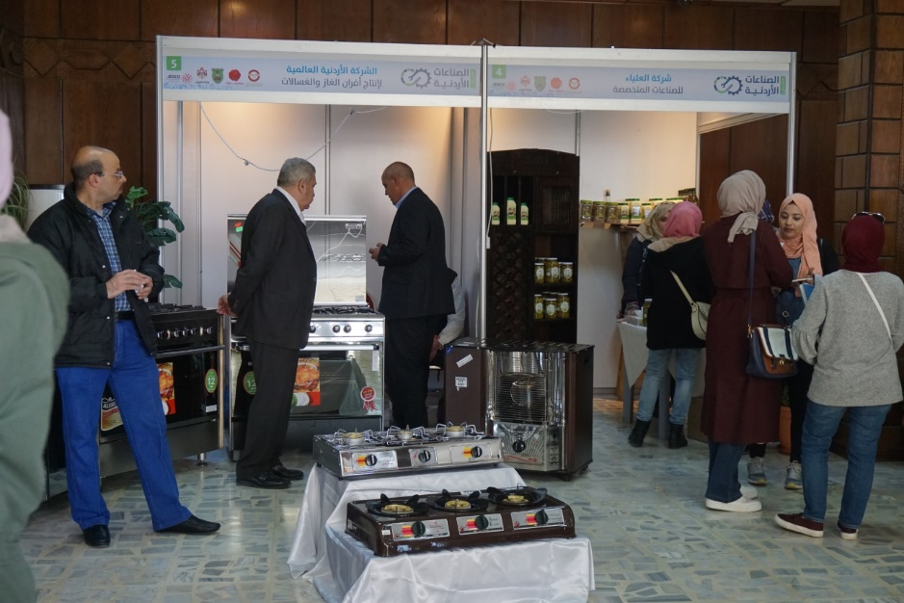

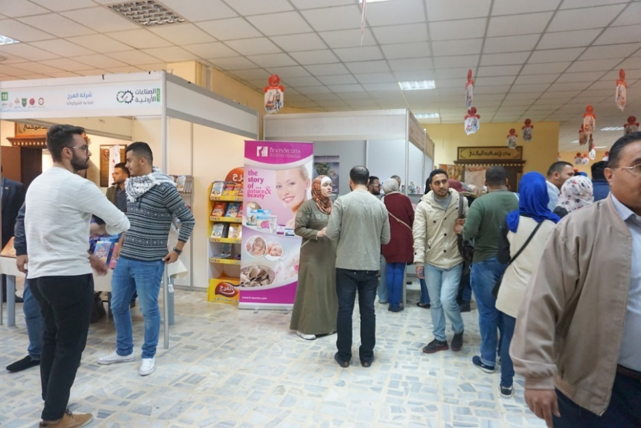

Another workshop entitled “Role of Science and Technology in industrial development: Innovation road map” was held on December 18, 2017. Speakers from distinguished organizations presented papers about innovation and connection between industry and Academia in order draw a map for innovation in Jordan. A full report is provided in external annex.

## Cooperation Agreements for sustainability

The CTI at UJ is cooperating with pioneering organizations and institutions to promote the innovation and entrepreneurship at the University of Jordan, three cooperation agreements were signed, and about other 8 agreements are under processing.

The signed agreements are as follow:

1. Cooperation agreement between the University of Jordan and “INJAZ” to provide services and programs in innovation and entrepreneurship.
2. Cooperation agreement between “INTAJ” and The University of Jordan for Entrepreneurship promotion in the information technology sector.
3. Cooperation agreement between “ Amman Chamber of Industry ” and The university of Jordan to connect the research at UJ with the industrial sector.

## The implementation of Innovation and Creativity courses

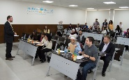

30 students at the University of Jordan have succeeded in establishing six projects for startup companies holding creativity and innovation. They introduced their projects during Special topics course (Innovation and Creativity) delivered by Dr. Youssef Al Abdullat at Industrial Engineering department at the University of Jordan, reflecting the bright and true image of the University of Jordan.

The main goal of this course is to open horizons for students to navigate ideas and feel the way of creativity and innovation through scientific knowledge.

The students learned a set of advanced skills starting with the preparation of market studies, the formation of teams and passing by making an action plan to distribute it in an administrative and economic way.

Equipping students with leadership skills in parallel with their academic specialization would make a significant contribution to the business market through their own projects relying on themselves to achieve the development and prosperity of society. The course is considered an opportunity for large companies to attract outstanding students, encourage their progress, and support knowledge-based economy.

The projects evaluation committee was formed by: Abdul Hameed Shoman foundation, Valentina Kassisieh, Abdul Majeed Shoman, Dina Al Saudi of the Seven Chambers Company, Saja Jaber of Osines 500 and Tamara Toukan of Spark.

The full agreements are provided in external annexes.

## The Regional Seminar on "Technological Innovation in Water for Sustainable Development"*

The seminar was held on 26-28 June 2018, covering different topics in innovation in the water sector Like innovative Wastewater treatment Technologies, Innovative Technology in sanitation and water sector Innovative rain water harvesting techniques and sustainable food production, addressing climate change impact, The role of the Omani Water Association in promoting research and innovation in the water sector.

The aim was to conduct the Innovation part in water sector in Jordan and Arab region.

*Full report is available

